Validation de l'IP d'acquisition GNSS
Analyse comparative CPU LUT vs FPGA IP
Rapport genere automatiquement

1. Parametres de campagne
Parametre | Valeur
Frequence echantillonnage (fs) | 11.999 MHz
Frequence intermediaire (IF) | 3.563 MHz
Nombre echantillons (N) | 11999
Nombre phases code (nb_phases) | 1023
Plage Doppler | [-10000, 10000] Hz
Pas Doppler (fd_step) | 500 Hz
Nb frequences Doppler | 18
Seuil detection (ratio_min) | 2.5
Marge robuste (winner_margin_db_min) | 3.0 dB
Tolerance Doppler | 500 Hz
Tolerance Phase | 3 chips
PRN injecte | [25]
PRN leurres par signal | 8
Nombre de fichiers signal | 86
Plage SNR | [-20.0, -10.0, 0.0, 10.0, 20.0]
Methodes comparees | CPU LUT angles vs FPGA IP

2. Resultats globaux par methode
Metriques agregees pour chaque methode sur l'ensemble de la campagne.
method | n_signaux | n_acquisitions | succes_strict_pct | Pd_pct | Pfa_pct | Pm_pct | doppler_mae_hz | doppler_max_hz | phase_mae_chip | phase_max_chip | peak_ratio_mean | peak_ratio_std | winner_margin_mean_db | winner_margin_min_db | time_mean_ms | time_median_ms | label
cpu_lut_angles | 86 | 86 | 98.8372 | 98.8372 | 0.0000 | 1.1628 | 3.0233 | 250 | 0.0000 | 0 | 573.1862 | 371.0909 | 14.2338 | 2.8424 | 108826.7187 | 108701.1567 | CPU LUT
fpga | 86 | 86 | 98.8372 | 98.8372 | 0.0000 | 1.1628 | 3.0233 | 250 | 0.0000 | 0 | 563.1032 | 367.1266 | 14.2307 | 2.8900 | 2010.5642 | 2010.5936 | FPGA IP

3. Resultats par SNR
Ventilation des performances par niveau de rapport signal-sur-bruit.
method | snr_db | n | succes_strict_pct | Pd_pct | Pfa_pct | Pm_pct | doppler_mae_hz | phase_mae_chip | peak_ratio_mean | winner_margin_mean_db | time_mean_ms | label
cpu_lut_angles | -20.0000 | 18 | 94.4444 | 94.4444 | 0.0000 | 5.5556 | 14.4444 | 0.0000 | 34.6565 | 3.9278 | 108672.6933 | CPU LUT
fpga | -20.0000 | 18 | 94.4444 | 94.4444 | 0.0000 | 5.5556 | 14.4444 | 0.0000 | 34.2108 | 3.9845 | 2010.5469 | FPGA IP
cpu_lut_angles | -10.0000 | 17 | 100.0000 | 100.0000 | 0.0000 | 0.0000 | 0.0000 | 0.0000 | 255.1798 | 12.5996 | 109284.6090 | CPU LUT
fpga | -10.0000 | 17 | 100.0000 | 100.0000 | 0.0000 | 0.0000 | 0.0000 | 0.0000 | 244.0307 | 12.6094 | 2010.5481 | FPGA IP
cpu_lut_angles | 0.0000 | 17 | 100.0000 | 100.0000 | 0.0000 | 0.0000 | 0.0000 | 0.0000 | 762.9986 | 17.6971 | 108674.5858 | CPU LUT
fpga | 0.0000 | 17 | 100.0000 | 100.0000 | 0.0000 | 0.0000 | 0.0000 | 0.0000 | 746.8107 | 17.5900 | 2010.6626 | FPGA IP
cpu_lut_angles | 10.0000 | 17 | 100.0000 | 100.0000 | 0.0000 | 0.0000 | 0.0000 | 0.0000 | 915.1268 | 18.7132 | 108764.1194 | CPU LUT
fpga | 10.0000 | 17 | 100.0000 | 100.0000 | 0.0000 | 0.0000 | 0.0000 | 0.0000 | 903.4100 | 18.7234 | 2010.5840 | FPGA IP
cpu_lut_angles | 20.0000 | 17 | 100.0000 | 100.0000 | 0.0000 | 0.0000 | 0.0000 | 0.0000 | 929.6476 | 18.8375 | 108746.6464 | CPU LUT
fpga | 20.0000 | 17 | 100.0000 | 100.0000 | 0.0000 | 0.0000 | 0.0000 | 0.0000 | 918.1650 | 18.8491 | 2010.4804 | FPGA IP

3.1. Detection, fausse alarme et miss vs SNR
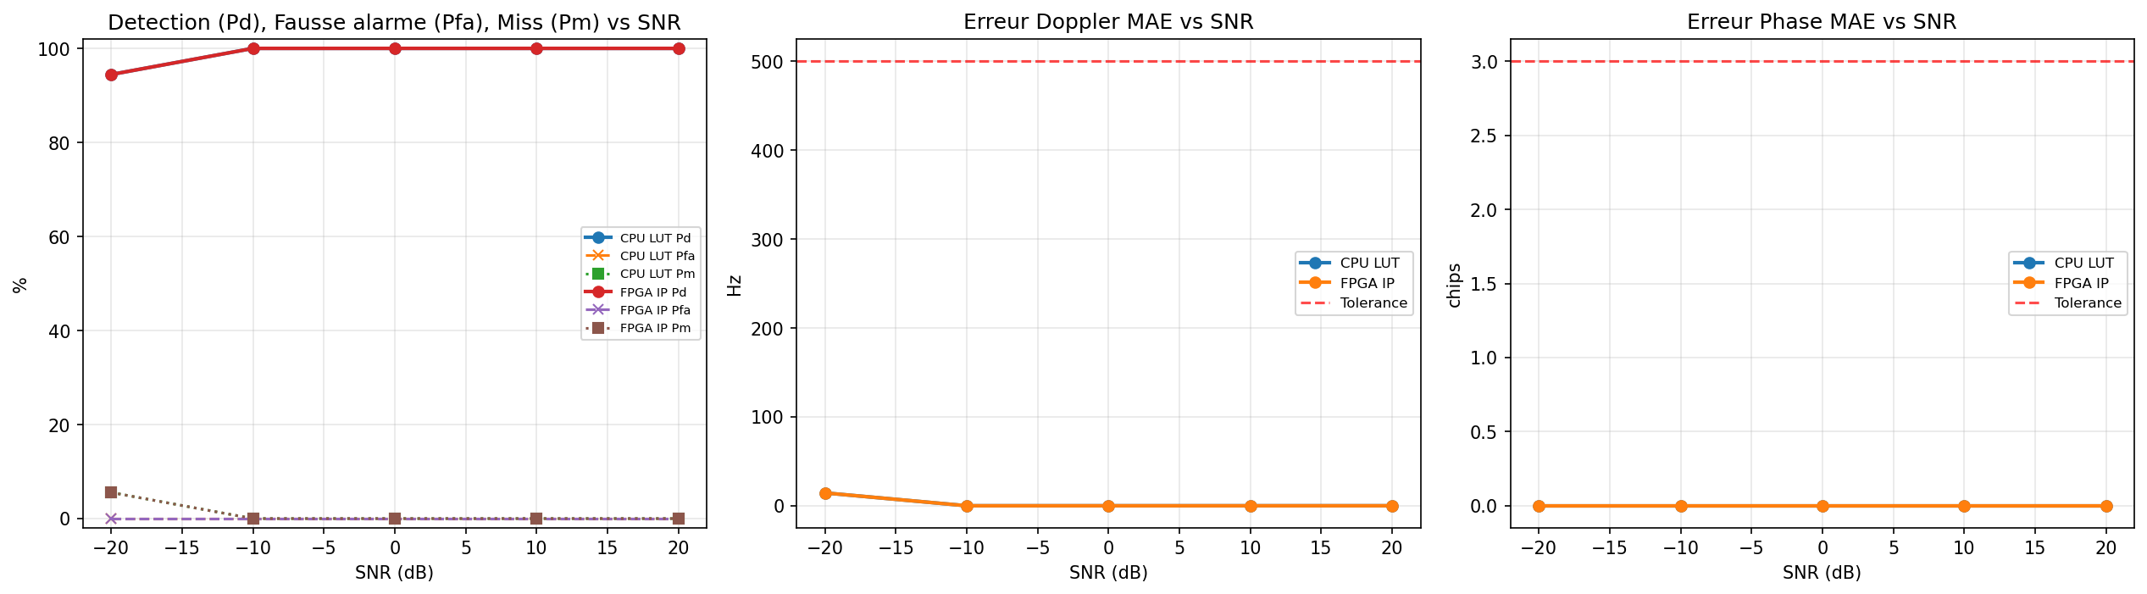

4. Analyse PFA sur PRN leurres

4.1. Volume injecte vs leurres
method | type | n
cpu_lut_angles | PRN injecte | 86
cpu_lut_angles | PRN leurre | 688
fpga | PRN injecte | 86
fpga | PRN leurre | 688

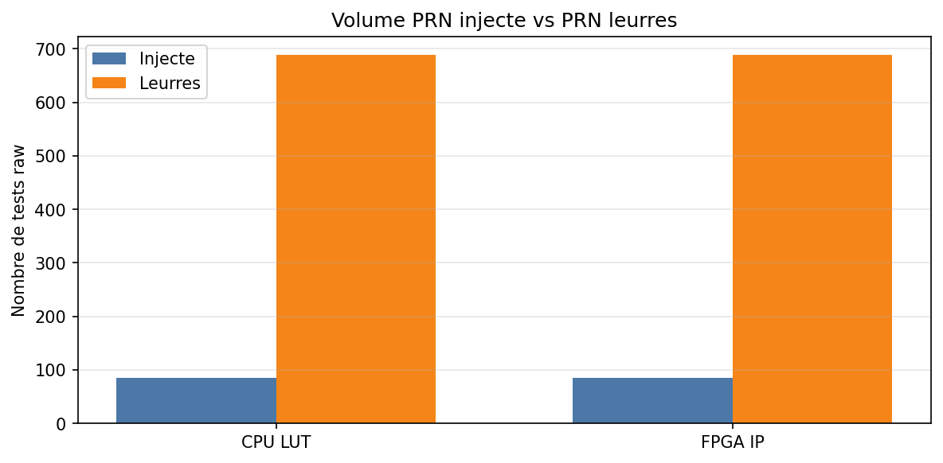

4.2. PFA globale
method | n_leurres | n_fausses_detections | Pfa_leurres_pct | peak_ratio_leurre_mean | peak_ratio_leurre_max | label
cpu_lut_angles | 688 | 688 | 100.0000 | 11.1947 | 15.7394 | CPU LUT
fpga | 688 | 688 | 100.0000 | 11.1377 | 16.1486 | FPGA IP

4.3. PFA par SNR
method | snr_db | n_leurres | n_fausses_det | Pfa_pct | peak_ratio_max | label
cpu_lut_angles | -20.0000 | 144 | 144 | 100.0000 | 15.6371 | CPU LUT
fpga | -20.0000 | 144 | 144 | 100.0000 | 16.0955 | FPGA IP
cpu_lut_angles | -10.0000 | 136 | 136 | 100.0000 | 15.7394 | CPU LUT
fpga | -10.0000 | 136 | 136 | 100.0000 | 16.1486 | FPGA IP
cpu_lut_angles | 0.0000 | 136 | 136 | 100.0000 | 14.2527 | CPU LUT
fpga | 0.0000 | 136 | 136 | 100.0000 | 14.6451 | FPGA IP
cpu_lut_angles | 10.0000 | 136 | 136 | 100.0000 | 15.0838 | CPU LUT
fpga | 10.0000 | 136 | 136 | 100.0000 | 14.0510 | FPGA IP
cpu_lut_angles | 20.0000 | 136 | 136 | 100.0000 | 13.8716 | CPU LUT
fpga | 20.0000 | 136 | 136 | 100.0000 | 12.8751 | FPGA IP

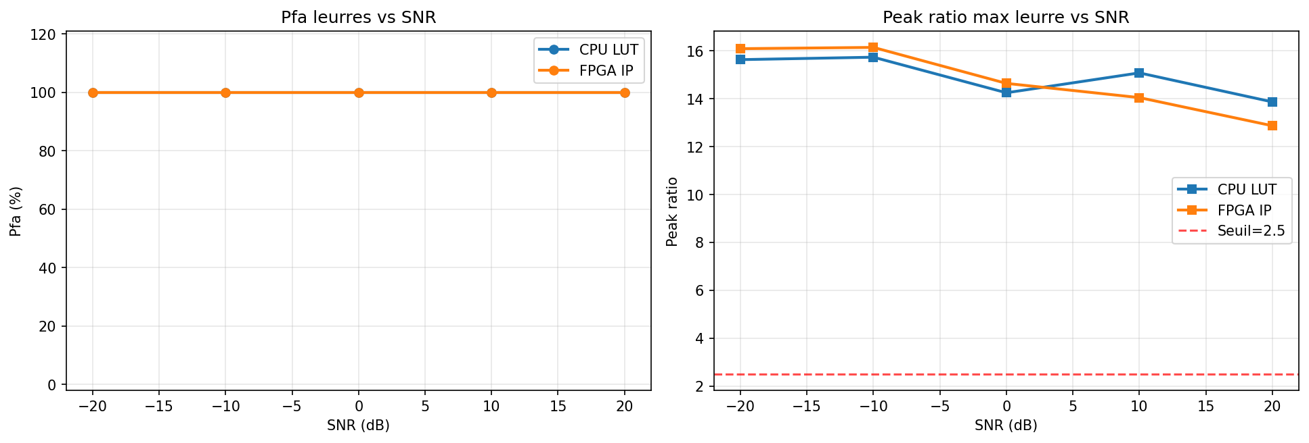

4.4. PFA par PRN leurre
method | prn_tested | n | n_false | Pfa_pct | peak_ratio_mean
cpu_lut_angles | 1 | 16 | 16 | 100.0000 | 11.3868
cpu_lut_angles | 2 | 27 | 27 | 100.0000 | 10.5969
cpu_lut_angles | 3 | 20 | 20 | 100.0000 | 11.0166
cpu_lut_angles | 4 | 17 | 17 | 100.0000 | 11.0274
cpu_lut_angles | 5 | 21 | 21 | 100.0000 | 10.9948
cpu_lut_angles | 6 | 16 | 16 | 100.0000 | 11.2038
cpu_lut_angles | 7 | 27 | 27 | 100.0000 | 12.3652
cpu_lut_angles | 8 | 20 | 20 | 100.0000 | 10.9181
cpu_lut_angles | 9 | 19 | 19 | 100.0000 | 10.3729
cpu_lut_angles | 10 | 20 | 20 | 100.0000 | 11.4122
cpu_lut_angles | 11 | 23 | 23 | 100.0000 | 11.3114
cpu_lut_angles | 12 | 17 | 17 | 100.0000 | 11.1962
cpu_lut_angles | 13 | 25 | 25 | 100.0000 | 11.7307
cpu_lut_angles | 14 | 17 | 17 | 100.0000 | 11.4122
cpu_lut_angles | 15 | 30 | 30 | 100.0000 | 11.1794
cpu_lut_angles | 16 | 28 | 28 | 100.0000 | 11.4473
cpu_lut_angles | 17 | 18 | 18 | 100.0000 | 10.3663
cpu_lut_angles | 18 | 18 | 18 | 100.0000 | 11.3813
cpu_lut_angles | 19 | 27 | 27 | 100.0000 | 11.0341
cpu_lut_angles | 20 | 29 | 29 | 100.0000 | 10.9524
cpu_lut_angles | 21 | 18 | 18 | 100.0000 | 11.4319
cpu_lut_angles | 22 | 24 | 24 | 100.0000 | 11.2996
cpu_lut_angles | 23 | 27 | 27 | 100.0000 | 11.6576
cpu_lut_angles | 24 | 25 | 25 | 100.0000 | 11.3028
cpu_lut_angles | 26 | 20 | 20 | 100.0000 | 10.9440
cpu_lut_angles | 27 | 17 | 17 | 100.0000 | 10.7037
cpu_lut_angles | 28 | 24 | 24 | 100.0000 | 11.3168
cpu_lut_angles | 29 | 19 | 19 | 100.0000 | 11.5414
cpu_lut_angles | 30 | 27 | 27 | 100.0000 | 11.4383
cpu_lut_angles | 31 | 26 | 26 | 100.0000 | 10.8203
cpu_lut_angles | 32 | 26 | 26 | 100.0000 | 10.8186
fpga | 1 | 16 | 16 | 100.0000 | 11.3420
fpga | 2 | 27 | 27 | 100.0000 | 10.5563
fpga | 3 | 20 | 20 | 100.0000 | 10.9533
fpga | 4 | 17 | 17 | 100.0000 | 11.2950
fpga | 5 | 21 | 21 | 100.0000 | 11.1176
fpga | 6 | 16 | 16 | 100.0000 | 11.2595
fpga | 7 | 27 | 27 | 100.0000 | 11.6482
fpga | 8 | 20 | 20 | 100.0000 | 11.0200
fpga | 9 | 19 | 19 | 100.0000 | 10.3305
fpga | 10 | 20 | 20 | 100.0000 | 11.3787
fpga | 11 | 23 | 23 | 100.0000 | 11.2636
fpga | 12 | 17 | 17 | 100.0000 | 11.0302
fpga | 13 | 25 | 25 | 100.0000 | 11.5494
fpga | 14 | 17 | 17 | 100.0000 | 11.2099
fpga | 15 | 30 | 30 | 100.0000 | 11.1676
fpga | 16 | 28 | 28 | 100.0000 | 11.3316
fpga | 17 | 18 | 18 | 100.0000 | 10.3265
fpga | 18 | 18 | 18 | 100.0000 | 11.4576
fpga | 19 | 27 | 27 | 100.0000 | 11.2195
fpga | 20 | 29 | 29 | 100.0000 | 10.7343
fpga | 21 | 18 | 18 | 100.0000 | 11.3665
fpga | 22 | 24 | 24 | 100.0000 | 11.4723
fpga | 23 | 27 | 27 | 100.0000 | 11.9032
fpga | 24 | 25 | 25 | 100.0000 | 11.1083
fpga | 26 | 20 | 20 | 100.0000 | 10.6240
fpga | 27 | 17 | 17 | 100.0000 | 10.7875
fpga | 28 | 24 | 24 | 100.0000 | 11.3815
fpga | 29 | 19 | 19 | 100.0000 | 11.4117
fpga | 30 | 27 | 27 | 100.0000 | 11.1472
fpga | 31 | 26 | 26 | 100.0000 | 10.8416
fpga | 32 | 26 | 26 | 100.0000 | 10.7900

4.5. Peak Ratio injecte vs leurres
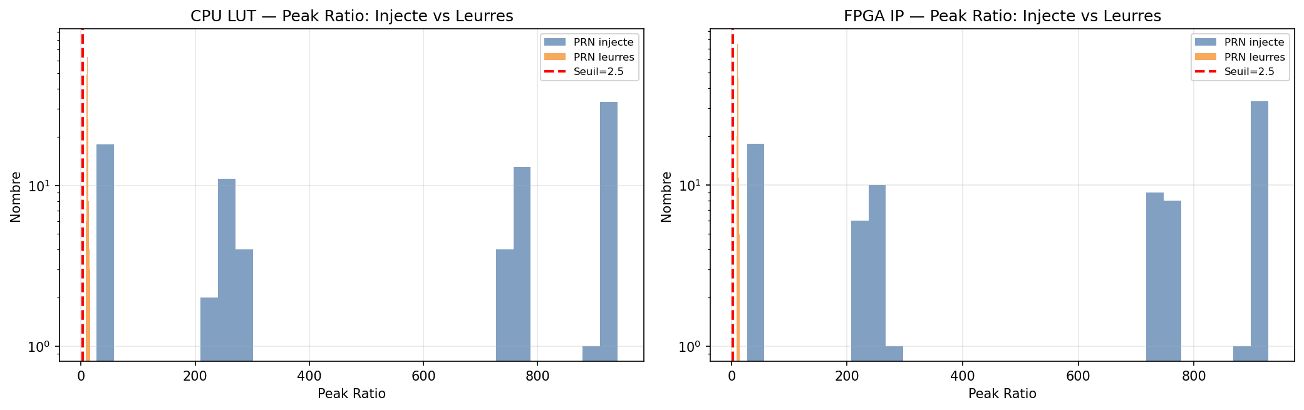

5. Concordance CPU LUT vs FPGA IP

5.1. Concordance globale
gauche | droite | n_commun | accord_decision_pct | accord_prn_pct | accord_doppler_exact_pct | accord_phase_exact_pct | delta_doppler_moy_hz | delta_phase_moy_chip | delta_peak_ratio_moy | delta_peak_ratio_max | delta_margin_moy_db | correlation_peak_ratio
CPU LUT | FPGA IP | 86 | 97.6744 | 100.0000 | 100.0000 | 100.0000 | 0.0000 | 0.0000 | 10.1101 | 16.6822 | 0.2263 | 1.0000

5.2. Concordance par SNR
snr_db | n | accord_decision_pct | accord_doppler_pct | accord_phase_pct | delta_peak_ratio_moy
-20.0000 | 18 | 88.8889 | 100.0000 | 100.0000 | 0.5750
-10.0000 | 17 | 100.0000 | 100.0000 | 100.0000 | 11.1491
0.0000 | 17 | 100.0000 | 100.0000 | 100.0000 | 16.1879
10.0000 | 17 | 100.0000 | 100.0000 | 100.0000 | 11.7167
20.0000 | 17 | 100.0000 | 100.0000 | 100.0000 | 11.4826

5.3. Scatter CPU vs FPGA
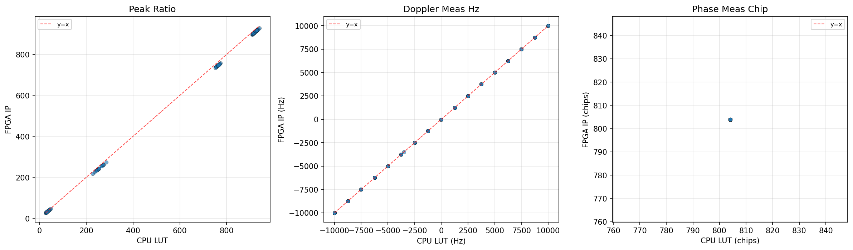

6. Graphiques detailles par methode

6.1. CPU LUT
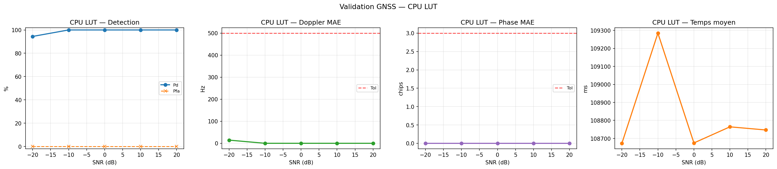
method | snr_db | n | succes_strict_pct | Pd_pct | Pfa_pct | Pm_pct | doppler_mae_hz | phase_mae_chip | peak_ratio_mean | winner_margin_mean_db | time_mean_ms | label
cpu_lut_angles | -20.0000 | 18 | 94.4444 | 94.4444 | 0.0000 | 5.5556 | 14.4444 | 0.0000 | 34.6565 | 3.9278 | 108672.6933 | CPU LUT
cpu_lut_angles | -10.0000 | 17 | 100.0000 | 100.0000 | 0.0000 | 0.0000 | 0.0000 | 0.0000 | 255.1798 | 12.5996 | 109284.6090 | CPU LUT
cpu_lut_angles | 0.0000 | 17 | 100.0000 | 100.0000 | 0.0000 | 0.0000 | 0.0000 | 0.0000 | 762.9986 | 17.6971 | 108674.5858 | CPU LUT
cpu_lut_angles | 10.0000 | 17 | 100.0000 | 100.0000 | 0.0000 | 0.0000 | 0.0000 | 0.0000 | 915.1268 | 18.7132 | 108764.1194 | CPU LUT
cpu_lut_angles | 20.0000 | 17 | 100.0000 | 100.0000 | 0.0000 | 0.0000 | 0.0000 | 0.0000 | 929.6476 | 18.8375 | 108746.6464 | CPU LUT

6.2. FPGA IP
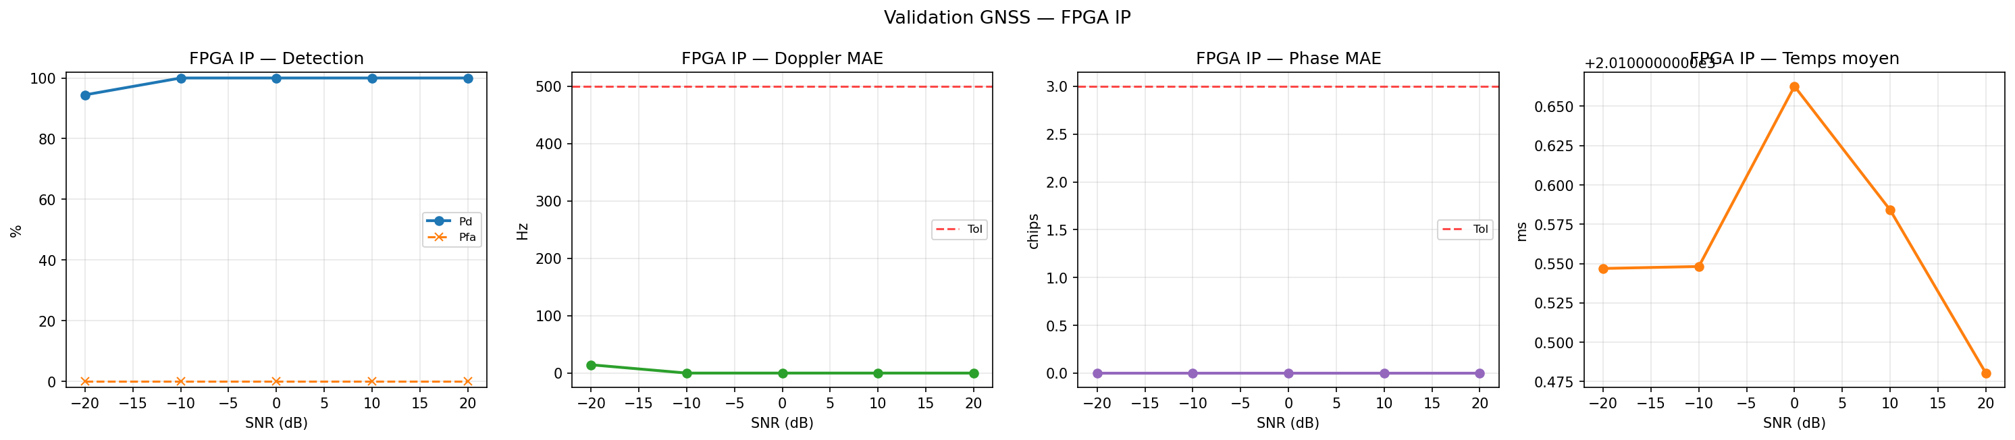
method | snr_db | n | succes_strict_pct | Pd_pct | Pfa_pct | Pm_pct | doppler_mae_hz | phase_mae_chip | peak_ratio_mean | winner_margin_mean_db | time_mean_ms | label
fpga | -20.0000 | 18 | 94.4444 | 94.4444 | 0.0000 | 5.5556 | 14.4444 | 0.0000 | 34.2108 | 3.9845 | 2010.5469 | FPGA IP
fpga | -10.0000 | 17 | 100.0000 | 100.0000 | 0.0000 | 0.0000 | 0.0000 | 0.0000 | 244.0307 | 12.6094 | 2010.5481 | FPGA IP
fpga | 0.0000 | 17 | 100.0000 | 100.0000 | 0.0000 | 0.0000 | 0.0000 | 0.0000 | 746.8107 | 17.5900 | 2010.6626 | FPGA IP
fpga | 10.0000 | 17 | 100.0000 | 100.0000 | 0.0000 | 0.0000 | 0.0000 | 0.0000 | 903.4100 | 18.7234 | 2010.5840 | FPGA IP
fpga | 20.0000 | 17 | 100.0000 | 100.0000 | 0.0000 | 0.0000 | 0.0000 | 0.0000 | 918.1650 | 18.8491 | 2010.4804 | FPGA IP

7. Heatmaps succes strict SNR x Doppler

7.1. CPU LUT
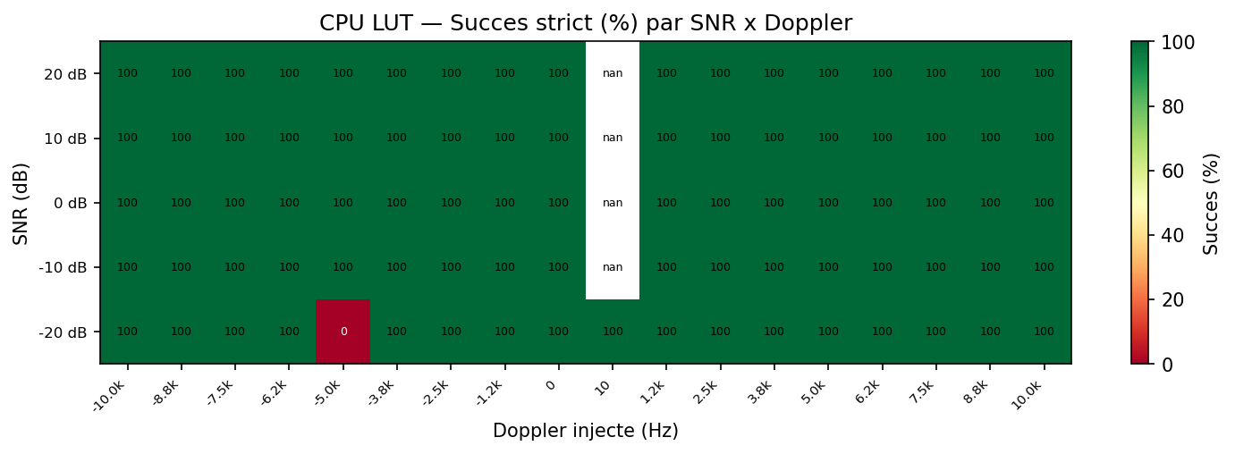
SNR (dB) | -10000 | -8750 | -7500 | -6250 | -5000 | -3750 | -2500 | -1250 | 0 | 10 | 1250 | 2500 | 3750 | 5000 | 6250 | 7500 | 8750 | 10000
-20.0000 | 100.0000 | 100.0000 | 100.0000 | 100.0000 | 0.0000 | 100.0000 | 100.0000 | 100.0000 | 100.0000 | 100.0000 | 100.0000 | 100.0000 | 100.0000 | 100.0000 | 100.0000 | 100.0000 | 100.0000 | 100.0000
-10.0000 | 100.0000 | 100.0000 | 100.0000 | 100.0000 | 100.0000 | 100.0000 | 100.0000 | 100.0000 | 100.0000 |  | 100.0000 | 100.0000 | 100.0000 | 100.0000 | 100.0000 | 100.0000 | 100.0000 | 100.0000
0.0000 | 100.0000 | 100.0000 | 100.0000 | 100.0000 | 100.0000 | 100.0000 | 100.0000 | 100.0000 | 100.0000 |  | 100.0000 | 100.0000 | 100.0000 | 100.0000 | 100.0000 | 100.0000 | 100.0000 | 100.0000
10.0000 | 100.0000 | 100.0000 | 100.0000 | 100.0000 | 100.0000 | 100.0000 | 100.0000 | 100.0000 | 100.0000 |  | 100.0000 | 100.0000 | 100.0000 | 100.0000 | 100.0000 | 100.0000 | 100.0000 | 100.0000
20.0000 | 100.0000 | 100.0000 | 100.0000 | 100.0000 | 100.0000 | 100.0000 | 100.0000 | 100.0000 | 100.0000 |  | 100.0000 | 100.0000 | 100.0000 | 100.0000 | 100.0000 | 100.0000 | 100.0000 | 100.0000

7.2. FPGA IP
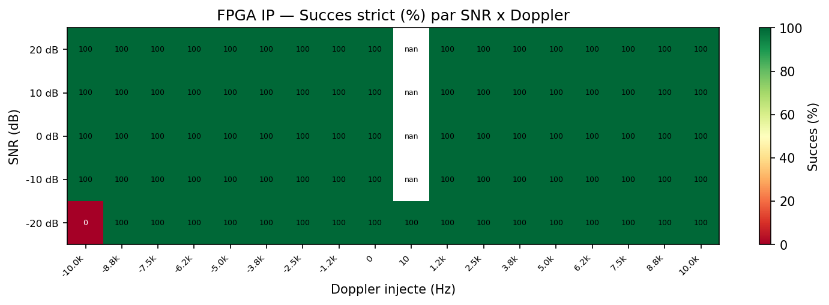
SNR (dB) | -10000 | -8750 | -7500 | -6250 | -5000 | -3750 | -2500 | -1250 | 0 | 10 | 1250 | 2500 | 3750 | 5000 | 6250 | 7500 | 8750 | 10000
-20.0000 | 0.0000 | 100.0000 | 100.0000 | 100.0000 | 100.0000 | 100.0000 | 100.0000 | 100.0000 | 100.0000 | 100.0000 | 100.0000 | 100.0000 | 100.0000 | 100.0000 | 100.0000 | 100.0000 | 100.0000 | 100.0000
-10.0000 | 100.0000 | 100.0000 | 100.0000 | 100.0000 | 100.0000 | 100.0000 | 100.0000 | 100.0000 | 100.0000 |  | 100.0000 | 100.0000 | 100.0000 | 100.0000 | 100.0000 | 100.0000 | 100.0000 | 100.0000
0.0000 | 100.0000 | 100.0000 | 100.0000 | 100.0000 | 100.0000 | 100.0000 | 100.0000 | 100.0000 | 100.0000 |  | 100.0000 | 100.0000 | 100.0000 | 100.0000 | 100.0000 | 100.0000 | 100.0000 | 100.0000
10.0000 | 100.0000 | 100.0000 | 100.0000 | 100.0000 | 100.0000 | 100.0000 | 100.0000 | 100.0000 | 100.0000 |  | 100.0000 | 100.0000 | 100.0000 | 100.0000 | 100.0000 | 100.0000 | 100.0000 | 100.0000
20.0000 | 100.0000 | 100.0000 | 100.0000 | 100.0000 | 100.0000 | 100.0000 | 100.0000 | 100.0000 | 100.0000 |  | 100.0000 | 100.0000 | 100.0000 | 100.0000 | 100.0000 | 100.0000 | 100.0000 | 100.0000

8. Distributions des erreurs
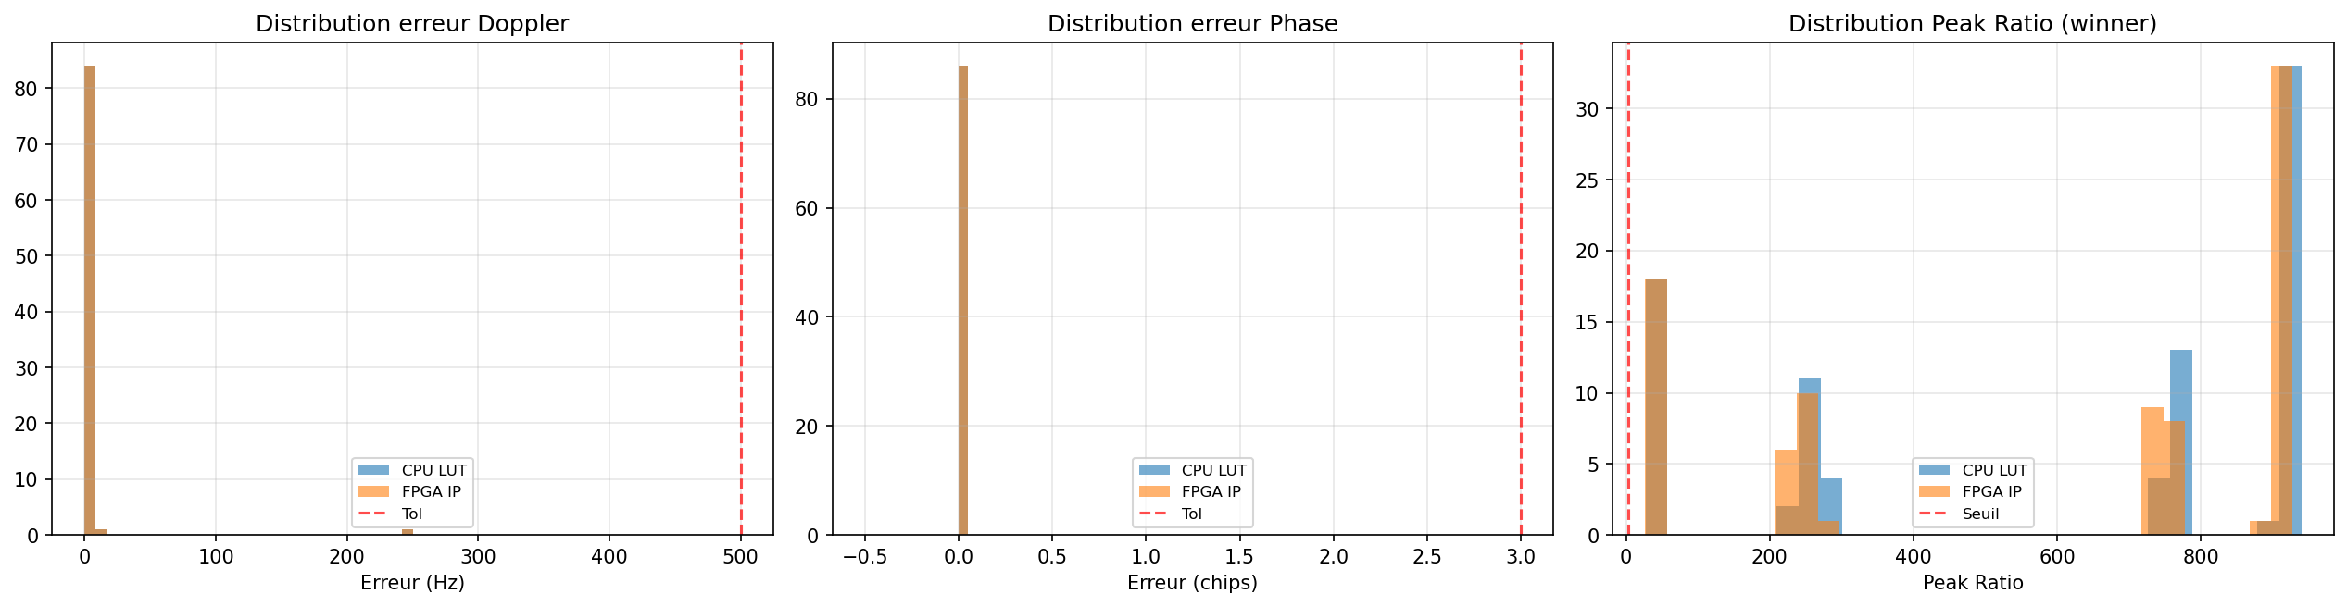

8.1. Statistiques erreurs par methode
method | doppler_err_mean | doppler_err_median | doppler_err_std | doppler_err_max | phase_err_mean | phase_err_median | phase_err_std | phase_err_max | peak_ratio_mean | peak_ratio_std | peak_ratio_min | peak_ratio_max | label
cpu_lut_angles | 3.0233 | 0.0000 | 26.9671 | 250 | 0.0000 | 0.0000 | 0.0000 | 0 | 573.1862 | 371.0909 | 27.1881 | 939.7426 | CPU LUT
fpga | 3.0233 | 0.0000 | 26.9671 | 250 | 0.0000 | 0.0000 | 0.0000 | 0 | 563.1032 | 367.1266 | 26.7454 | 927.9742 | FPGA IP

9. Boxplots Peak Ratio et Winner Margin par SNR
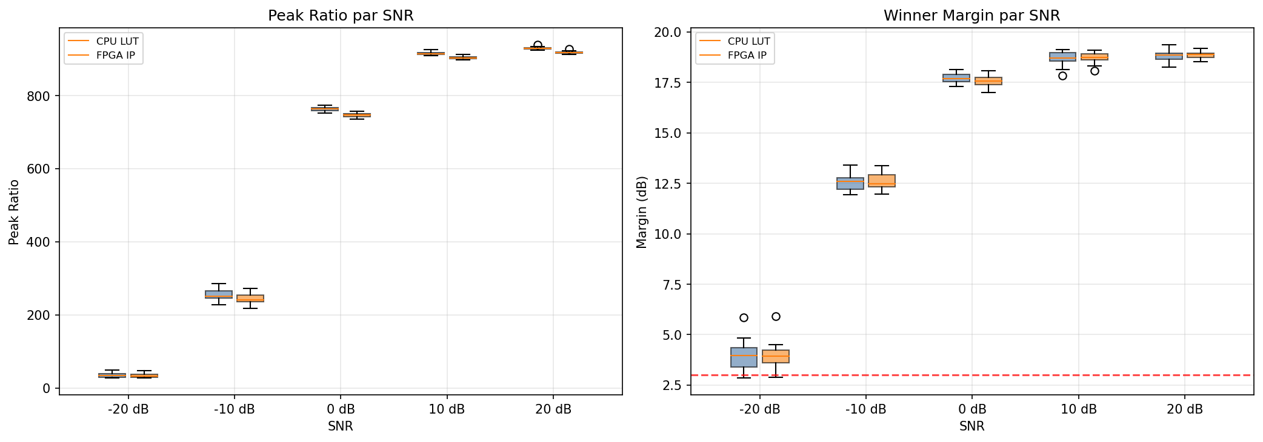
method | snr_db | peak_ratio_mean | peak_ratio_median | peak_ratio_min | peak_ratio_max | margin_mean_db | margin_min_db | margin_max_db
cpu_lut_angles | -20.0000 | 34.6565 | 33.8098 | 27.1881 | 48.5478 | 3.9278 | 2.8424 | 5.8472
fpga | -20.0000 | 34.2108 | 33.1401 | 26.7454 | 47.0250 | 3.9845 | 2.8900 | 5.9151
cpu_lut_angles | -10.0000 | 255.1798 | 251.5397 | 227.6662 | 286.2229 | 12.5996 | 11.9507 | 13.4209
fpga | -10.0000 | 244.0307 | 240.9751 | 218.4398 | 273.1376 | 12.6094 | 11.9800 | 13.3653
cpu_lut_angles | 0.0000 | 762.9986 | 763.8701 | 751.8743 | 773.2948 | 17.6971 | 17.2948 | 18.1499
fpga | 0.0000 | 746.8107 | 747.6910 | 735.6530 | 756.9355 | 17.5900 | 17.0098 | 18.0937
cpu_lut_angles | 10.0000 | 915.1268 | 914.9031 | 908.6946 | 925.0138 | 18.7132 | 17.8299 | 19.1215
fpga | 10.0000 | 903.4100 | 903.0773 | 897.1367 | 912.9620 | 18.7234 | 18.0822 | 19.1074
cpu_lut_angles | 20.0000 | 929.6476 | 929.4634 | 924.1012 | 939.7426 | 18.8375 | 18.2473 | 19.3825
fpga | 20.0000 | 918.1650 | 917.9727 | 912.7378 | 927.9742 | 18.8491 | 18.5284 | 19.1865

10. Cas difficiles
Signaux tries par echec puis par marge de robustesse croissante. Ces cas representent les limites du systeme.
file | method | snr_db | prn_injected | prn_winner | pd_flag | pfa_flag | pm_flag | doppler_true_hz | doppler_meas_hz | doppler_err_hz | phase_true_chip | phase_meas_chip | phase_err_chip | peak_ratio | second_peak_ratio | winner_margin_db | strict_success
gps-1ms_prn-25_fs-11MHz_if-3563kHz_snr-n20_doppler-n5000Hz_ca-804.csv | cpu_lut_angles | -20.0000 | 25 | 25 | 0 | 0 | 1 | -5000 | -5000 | 0 | 804 | 804 | 0 | 29.8026 | 15.4886 | 2.8424 | 0
gps-1ms_prn-25_fs-11MHz_if-3563kHz_snr-n20_doppler-n10000Hz_ca-804.csv | fpga | -20.0000 | 25 | 25 | 0 | 0 | 1 | -10000 | -10000 | 0 | 804 | 804 | 0 | 26.9462 | 13.8516 | 2.8900 | 0
gps-1ms_prn-25_fs-11MHz_if-3563kHz_snr-n20_doppler-n10000Hz_ca-804.csv | cpu_lut_angles | -20.0000 | 25 | 25 | 1 | 0 | 0 | -10000 | -10000 | 0 | 804 | 804 | 0 | 27.1881 | 13.3631 | 3.0847 | 1
gps-1ms_prn-25_fs-11MHz_if-3563kHz_snr-n20_doppler-p7500Hz_ca-804.csv | cpu_lut_angles | -20.0000 | 25 | 25 | 1 | 0 | 0 | 7500 | 7500 | 0 | 804 | 804 | 0 | 31.8641 | 15.6371 | 3.0914 | 1
gps-1ms_prn-25_fs-11MHz_if-3563kHz_snr-n20_doppler-n3750Hz_ca-804.csv | cpu_lut_angles | -20.0000 | 25 | 25 | 1 | 0 | 0 | -3750 | -3500 | 250 | 804 | 804 | 0 | 27.3857 | 13.0291 | 3.2261 | 1
gps-1ms_prn-25_fs-11MHz_if-3563kHz_snr-n20_doppler-n3750Hz_ca-804.csv | fpga | -20.0000 | 25 | 25 | 1 | 0 | 0 | -3750 | -3500 | 250 | 804 | 804 | 0 | 28.0719 | 13.0701 | 3.3199 | 1
gps-1ms_prn-25_fs-11MHz_if-3563kHz_snr-n20_doppler-n8750Hz_ca-804.csv | cpu_lut_angles | -20.0000 | 25 | 25 | 1 | 0 | 0 | -8750 | -8750 | 0 | 804 | 804 | 0 | 28.8188 | 13.3338 | 3.3472 | 1
gps-1ms_prn-25_fs-11MHz_if-3563kHz_snr-n20_doppler-n5000Hz_ca-804.csv | fpga | -20.0000 | 25 | 25 | 1 | 0 | 0 | -5000 | -5000 | 0 | 804 | 804 | 0 | 29.6066 | 13.4417 | 3.4293 | 1
gps-1ms_prn-25_fs-11MHz_if-3563kHz_snr-n20_doppler-n8750Hz_ca-804.csv | fpga | -20.0000 | 25 | 25 | 1 | 0 | 0 | -8750 | -8750 | 0 | 804 | 804 | 0 | 28.5199 | 12.9371 | 3.4331 | 1
gps-1ms_prn-25_fs-11MHz_if-3563kHz_snr-n20_doppler-n7500Hz_ca-804.csv | cpu_lut_angles | -20.0000 | 25 | 25 | 1 | 0 | 0 | -7500 | -7500 | 0 | 804 | 804 | 0 | 29.8869 | 13.3642 | 3.4954 | 1
gps-1ms_prn-25_fs-11MHz_if-3563kHz_snr-n20_doppler-n6250Hz_ca-804.csv | cpu_lut_angles | -20.0000 | 25 | 25 | 1 | 0 | 0 | -6250 | -6250 | 0 | 804 | 804 | 0 | 27.2516 | 12.0207 | 3.5546 | 1
gps-1ms_prn-25_fs-11MHz_if-3563kHz_snr-n20_doppler-n6250Hz_ca-804.csv | fpga | -20.0000 | 25 | 25 | 1 | 0 | 0 | -6250 | -6250 | 0 | 804 | 804 | 0 | 26.7454 | 11.7686 | 3.5652 | 1
gps-1ms_prn-25_fs-11MHz_if-3563kHz_snr-n20_doppler-p0Hz_ca-804.csv | cpu_lut_angles | -20.0000 | 25 | 25 | 1 | 0 | 0 | 0 | 0 | 0 | 804 | 804 | 0 | 35.2641 | 15.4081 | 3.5958 | 1
gps-1ms_prn-25_fs-11MHz_if-3563kHz_snr-n20_doppler-p3750Hz_ca-804.csv | fpga | -20.0000 | 25 | 25 | 1 | 0 | 0 | 3750 | 3750 | 0 | 804 | 804 | 0 | 34.1965 | 14.5866 | 3.7003 | 1
gps-1ms_prn-25_fs-11MHz_if-3563kHz_snr-n20_doppler-p6250Hz_ca-804.csv | fpga | -20.0000 | 25 | 25 | 1 | 0 | 0 | 6250 | 6250 | 0 | 804 | 804 | 0 | 31.4176 | 13.0781 | 3.8063 | 1
gps-1ms_prn-25_fs-11MHz_if-3563kHz_snr-n20_doppler-n7500Hz_ca-804.csv | fpga | -20.0000 | 25 | 25 | 1 | 0 | 0 | -7500 | -7500 | 0 | 804 | 804 | 0 | 30.0210 | 12.4860 | 3.8100 | 1
gps-1ms_prn-25_fs-11MHz_if-3563kHz_snr-n20_doppler-p8750Hz_ca-804.csv | fpga | -20.0000 | 25 | 25 | 1 | 0 | 0 | 8750 | 8750 | 0 | 804 | 804 | 0 | 32.0837 | 13.2026 | 3.8563 | 1
gps-1ms_prn-25_fs-11MHz_if-3563kHz_snr-n20_doppler-p6250Hz_ca-804.csv | cpu_lut_angles | -20.0000 | 25 | 25 | 1 | 0 | 0 | 6250 | 6250 | 0 | 804 | 804 | 0 | 31.0744 | 12.6540 | 3.9017 | 1
gps-1ms_prn-25_fs-11MHz_if-3563kHz_snr-n20_doppler-p8750Hz_ca-804.csv | cpu_lut_angles | -20.0000 | 25 | 25 | 1 | 0 | 0 | 8750 | 8750 | 0 | 804 | 804 | 0 | 32.5489 | 12.8770 | 4.0272 | 1
gps-1ms_prn-25_fs-11MHz_if-3563kHz_snr-n20_doppler-p7500Hz_ca-804.csv | fpga | -20.0000 | 25 | 25 | 1 | 0 | 0 | 7500 | 7500 | 0 | 804 | 804 | 0 | 31.1464 | 12.3168 | 4.0291 | 1

11. Analyse de performance

11.1. Comparaison des temps
method | n | time_mean_ms | time_median_ms | time_p95_ms | time_p99_ms | e2e_mean_ms | speedup_vs_cpu | label
cpu_lut_angles | 86 | 108826.7187 | 108701.1567 | 108834.0481 | 112752.0122 | 109592.8025 | 1.0000 | CPU LUT
fpga | 86 | 2010.5642 | 2010.5936 | 2011.1288 | 2011.2123 | 2099.5809 | 54.1275 | FPGA IP

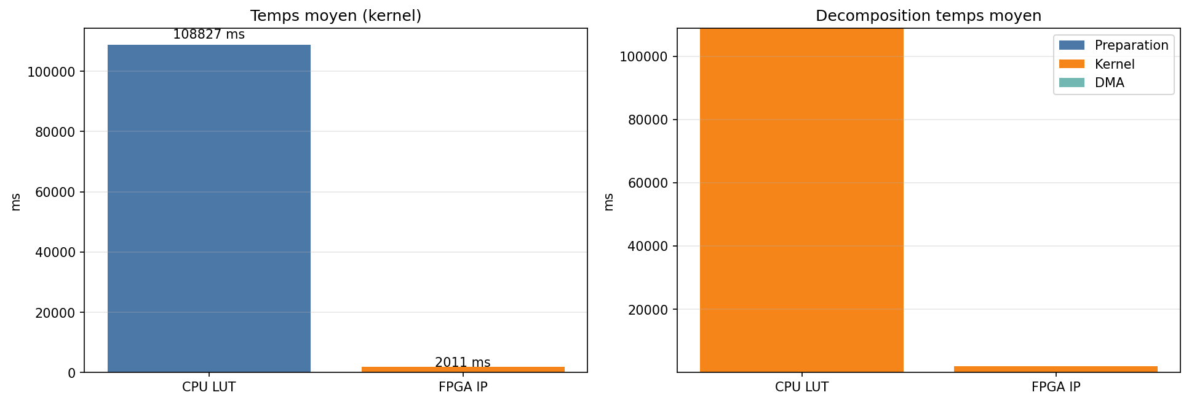

11.2. Profiling detaille
time_kernel_s_mean | time_kernel_s_median | time_kernel_s_std | time_kernel_s_min | time_kernel_s_max | time_prepare_s_mean | time_prepare_s_median | time_prepare_s_std | time_prepare_s_min | time_prepare_s_max | time_dma_s_mean | time_dma_s_median | time_dma_s_std | time_dma_s_min | time_dma_s_max | time_ip_wait_s_mean | time_ip_wait_s_median | time_ip_wait_s_std | time_ip_wait_s_min | time_ip_wait_s_max | time_end_to_end_s_mean | time_end_to_end_s_median | time_end_to_end_s_std | time_end_to_end_s_min | time_end_to_end_s_max
108.8267 | 108.7012 | 0.8352 | 108.5388 | 115.5373 | 0.0001 | 0.0001 | 0.0000 | 0.0001 | 0.0002 | 0.0000 | 0.0000 | 0.0000 | 0.0000 | 0.0000 | 0.0000 | 0.0000 | 0.0000 | 0.0000 | 0.0000 | 109.5928 | 109.4664 | 0.8391 | 109.3070 | 116.3126
2.0106 | 2.0106 | 0.0003 | 2.0100 | 2.0112 | 0.0706 | 0.0120 | 0.5255 | 0.0098 | 4.8868 | 0.0022 | 0.0022 | 0.0004 | 0.0018 | 0.0059 | 2.0106 | 2.0106 | 0.0003 | 2.0100 | 2.0112 | 2.0996 | 2.0411 | 0.5312 | 2.0367 | 6.9686

12. Domaine de validite
Resume du domaine dans lequel chaque methode produit un resultat strictement correct (PRN, Doppler et phase dans les tolerances).
method | label | snr_min_ok_db | snr_max_ok_db | doppler_min_ok_hz | doppler_max_ok_hz | n_succes | n_total | taux_succes_pct | doppler_max_err_hz | phase_max_err_chip
cpu_lut_angles | CPU LUT | -20.0000 | 20.0000 | -10000 | 10000 | 85 | 86 | 98.8400 | 250 | 0
fpga | FPGA IP | -20.0000 | 20.0000 | -10000 | 10000 | 85 | 86 | 98.8400 | 250 | 0

13. Resume final
Fichiers signal analyses: 86
SNR testes: [-20.0, -10.0, 0.0, 10.0, 20.0] dB
Plage Doppler: [-10000, 10000] Hz
PRN injecte: [25]
PRN leurres/signal: 8

--- CPU LUT (86 acquisitions) ---
Succes strict: 98.84%
Pd: 98.84% | Pfa: 0.00% | Pm: 1.16%
Doppler MAE: 3.02 Hz
Phase MAE: 0.00 chips
Temps kernel: 108826.7 ms

--- FPGA IP (86 acquisitions) ---
Succes strict: 98.84%
Pd: 98.84% | Pfa: 0.00% | Pm: 1.16%
Doppler MAE: 3.02 Hz
Phase MAE: 0.00 chips
Temps kernel: 2010.6 ms

--- CPU LUT PFA leurres (688 tests) ---
Fausses detections: 688
Pfa: 100.00%

--- FPGA IP PFA leurres (688 tests) ---
Fausses detections: 688
Pfa: 100.00%

--- Concordance CPU LUT vs FPGA IP ---
Accord decision: 97.67%
Accord PRN: 100.00%
Accord Doppler exact: 100.00%
Correlation peak ratio: 0.999953

Speedup FPGA vs CPU: 54.1x

